Image | 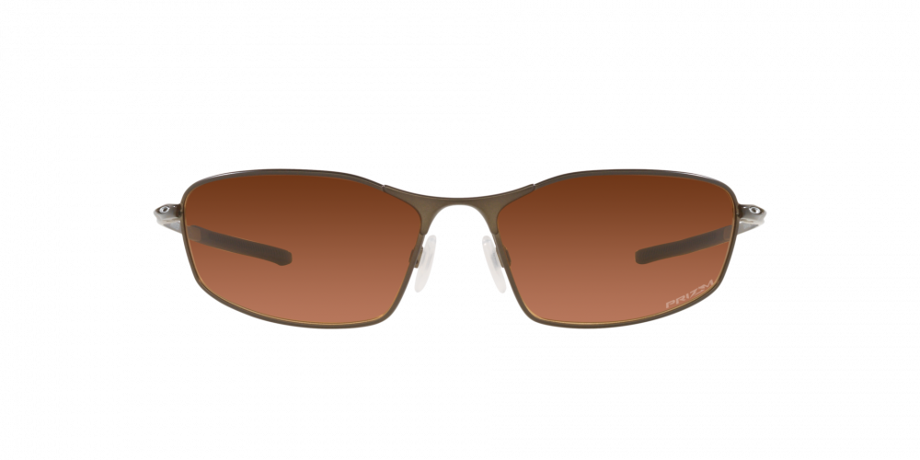
Brand | OAKLEY
Model Name | WHISKER PEWTER
Price | RS 1999
PRODUCT DETAILS

